Assignment 1:

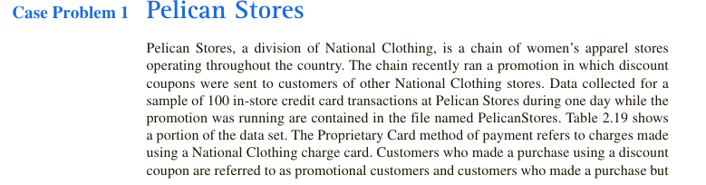



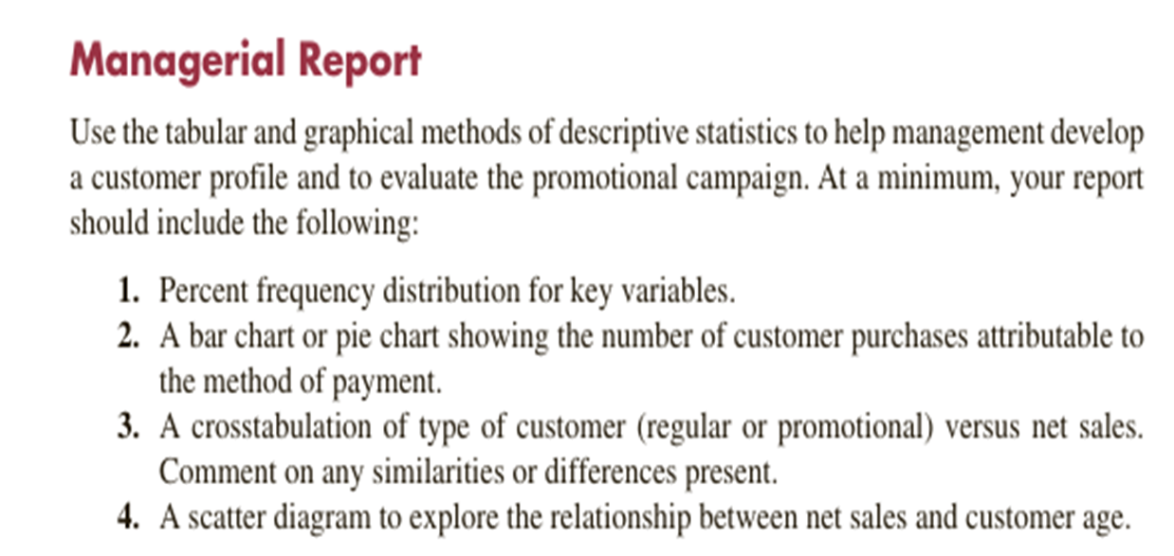

Source dataset: PelicanStores

2.

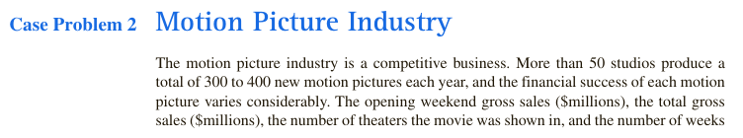

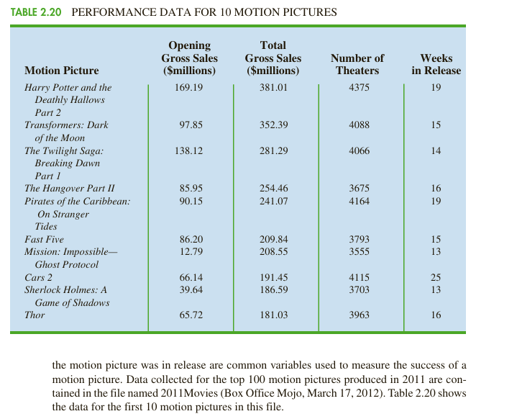

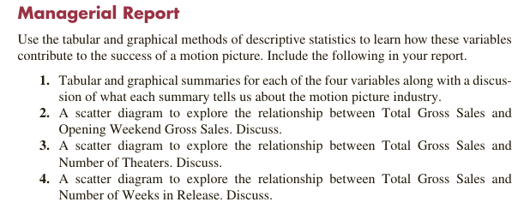

Source dataset: 2011Movies

3.

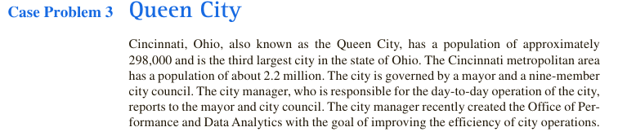

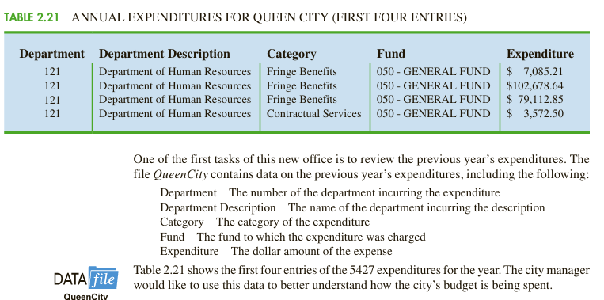

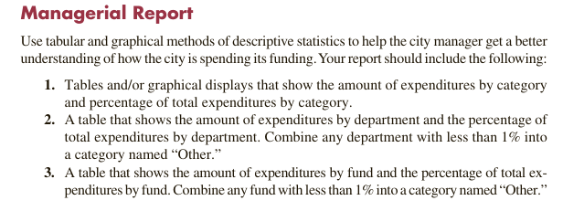

Source dataset: QueenCity

4.



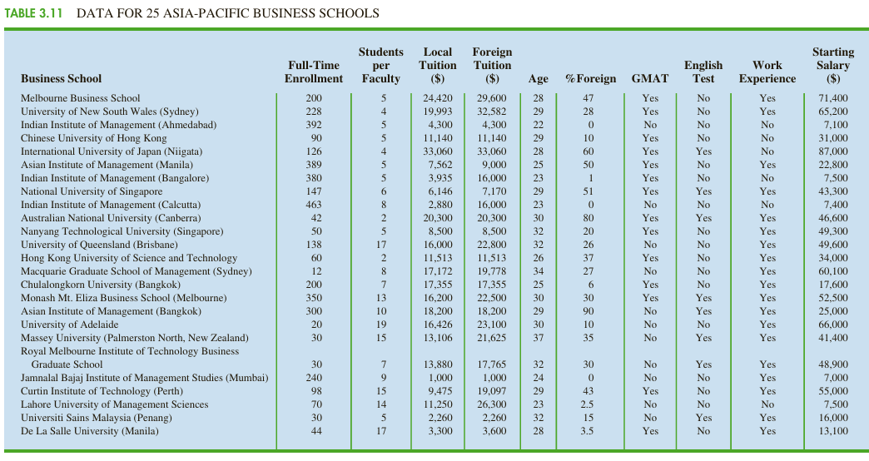

Source dataset: Asian

5.

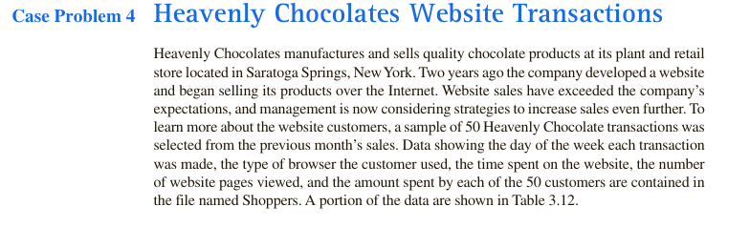

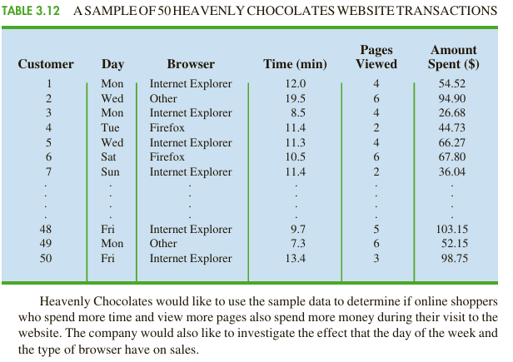

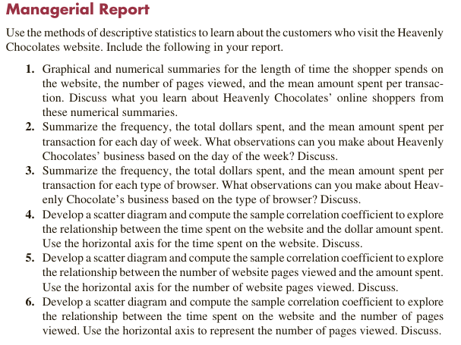

Source dataset: Shoppers

6.

In an article in the American Journal of Obstetrics and Gynecology, Dr. Giancarlo Mari discusses his study of arterial blood flow velocity waveforms of the perlvis and lower extremities in normal and growth-retarded fetuses. He states that his preliminary data suggest that the “femoral artery pulsatility index cannot be used as an indicator of adverse fetal outcome, whereas absent or reverse flow of the umbilical artery seems to be better correlated with adverse fetal outcome.”

The following are the gestational ages(in weeks) of 20 growith retarded fetuses that he studies.

24 26 27 28 28 28 29 30 30 31 32 32 33 33 34 34 35 35 35 36

Construct the box -and-whisker plot for these data and comment.

7.

Construct the comparative box plots for various phone services in major metropolitan areas in USA and comment.